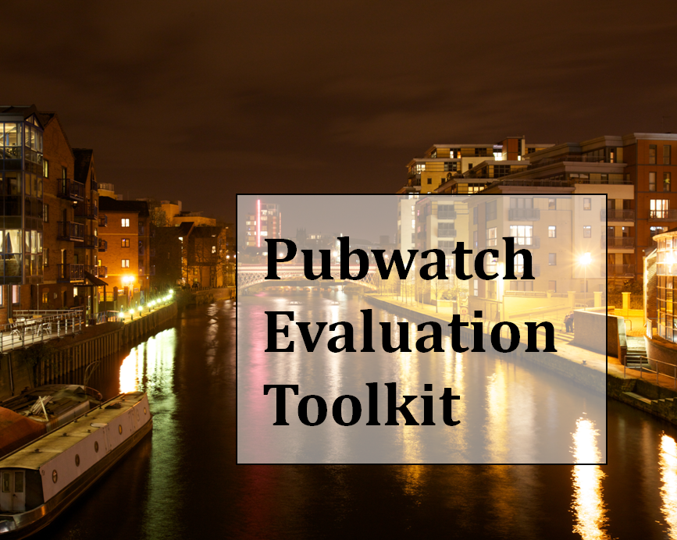

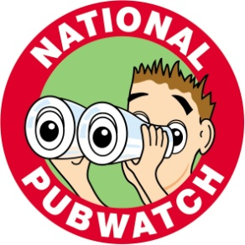 | 

Pubwatch Evaluation Toolkit: Collaboration between National Pubwatch and Leeds Beckett University
National Pubwatch in collaboration with Leeds Beckett University
Contents
1.0 What is a Pubwatch scheme? 1
2.0 What are the objectives of a local Pubwatch scheme? 1
3.0 Why should you evaluate your local Pubwatch scheme? 1
4.0 What are the local Pubwatch Evaluation Toolkits? 2
5.0 What does the Evaluation Toolkit involve? 2
6.0 What are the key steps involved in evaluation? 3
7.0 When should local Pubwatch scheme evaluations take place? 3
Appendices 4

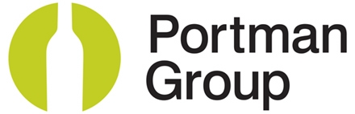

The Portman Group, on behalf of the Local Alcohol Partnership, provided the funding for Leeds Beckett University to develop the evaluation toolkit in partnership with the scheme

1.0 What is a Pubwatch scheme?

A Pubwatch scheme is a voluntary group of licensees working in an area who are concerned about local crime and safety issues in their pubs and bars and who come together to find solutions to address their local problems. National Pubwatch believes that a well-run and effective Pubwatch scheme promotes the licensing objectives and furthers the interests of its members, by helping to create a safe and secure drinking environment and reducing alcohol-related crime.

This Pubwatch Evaluation Toolkit provides you with information, processes and ways to provide evidence that your local Pubwatch scheme has helped to reduce alcohol-related crime, disorder in your town “after dark”*, build positive relationships within your town or city, improve data sharing and increase the feeling of safety for employees and consumers.

2.0 What are the objectives of a local Pubwatch scheme?

The overall aim of a local Pubwatch scheme is “to help create a safe and secure drinking environment and reduce alcohol-related crime”. To achieve that aim the objectives are:
Objective 1 | Reduce alcohol-related crime, disorder and anti-social behaviour
Objective 2 | Reduce alcohol-related health harm
Objective 3 | Build positive perceptions of the local Pubwatch scheme
Objective 4 | Build positive relationships between licensees and other invited guests present at Pubwatch meetings (invited guests include trade, police, local authorities and/or other agencies)
Objective 5 | Improve data sharing information about the night-time economy*
Objective 6 | Improve business performance during the night-time economy*
*Night-time economy is “after-dark”, defined as between 6pm and 6am.

If your Pubwatch scheme achieves the above objectives you will be able to say... “My Pubwatch Scheme works and here is the evidence to prove it.”

3.0 Why should you evaluate your local Pubwatch scheme?
Evaluating your local Pubwatch scheme is important to ascertain if the objectives of the local Pubwatch scheme are being achieved. Additionally, the evaluation will enable the Pubwatch Committee to:
- Support the continuation of the local Pubwatch team
- Improve the effectiveness/efficiency of the local Pubwatch scheme; based on lessons learn and feedback
- Understand the positive impact of the local Pubwatch scheme on your local area
- Assist in your communication with stakeholders
- Share best practice with other local Pubwatch schemes; locally and nationally
- Demonstrate good practice e.g. evidence to support an application to the National Pubwatch Awards*
*Click the link to visit the website of National Pubwatch http://www.nationalpubwatch.org.uk/

4.0 What are the local Pubwatch Evaluation Toolkits?
The local Pubwatch Evaluation Toolkit has been designed to measure the effectiveness of your scheme. The toolkit provides an evaluations framework, guidance on best practice regarding data collection for baseline measurement and Year-On-Year data collection. The data collected will be a combination of crime and disorder police data, licensee surveys and qualitative discussions with both licensees and key stakeholders.

The toolkit has been developed in partnership with Leeds Beckett University and contains two parts:

- Appendix 1: Baseline Evaluation Toolkit
- Appendix 2: Year-On-Year Evaluation Toolkit
- Appendix 2: Report Findings

5.0 What does the Evaluation Toolkit involve?
 | Purpose | Discussion with Licensees | Discussion with Stake-holders | On-line Licensee survey | Police Data
Baseline Evaluation | The Baseline Evaluation Toolkit provides an information base against which to monitor and assess the progress of your local Pubwatch scheme, its effectiveness and impact | Yes | Yes | Yes | Yes
Year-On-Year Evaluation | Following the Baseline Evaluation the Year-On-Year Evaluations are recommended to ascertain how your local Pubwatch scheme has contributed to improvements/changes to reducing crime and disorder and supporting local economic growth and continuous progress of your Pubwatch scheme on an ongoing basis | Yes | Yes | Yes | Yes

6.0 What are the key steps involved in evaluation?

Key Steps | Task | Toolkit
1. | Pre-Launch  Establish Timeline including dates when you will launch your local Pubwatch scheme  Agree who will:  Contact National Pubwatch who will provide advice to help you set up your scheme  Collect and analyse data  Report data
2. | Baseline Evaluation (See Appendix 1)  - Complete immediately after you have decided to launch your local Pubwatch  - Collect, analyse and evaluate Baseline data | Baseline Toolkit
3. | Year-On-Year Evaluation (See Appendix 2)  - Complete one year after launch and annually thereafter  Collect, analyse and evaluate Year-On-Year findings | Year-On-Year Toolkit
4* | Report Findings (See Appendix 3)  - Only report findings Year-On-Year | Outline to Report Findings

7.0 When should local Pubwatch scheme evaluations take place?
Effective evaluation is a continuing process and should be an integral part of your local Pubwatch scheme. Initially a baseline evaluation is carried out before the scheme is launched.
After that, Year-On-Year evaluations should take place and findings reported. Figure 1 below shows the basic steps involved in this process.

Figure 1 Step-by-Step Guide for the Evaluation Process

Appendices

Toolkits

Appendix 1 Baseline Evaluation Toolkit

Appendix 2 Year-On-Year Evaluation Toolkit

Appendix 3 Outline to Report Findings

Should you have any questions about collecting, evaluating and reporting your findings; or indeed any other issues affecting local Pubwatch scheme email us at admin@nationalpubwatch.org.uk

